**AWS EC2 Deployment using Ansible Playbook**

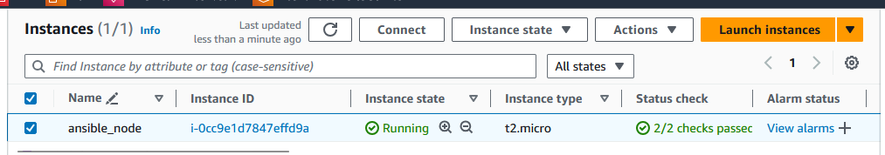

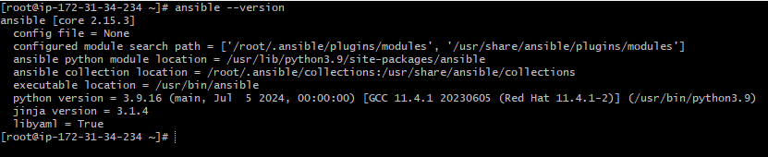

CREATE AN IAM ROLE:

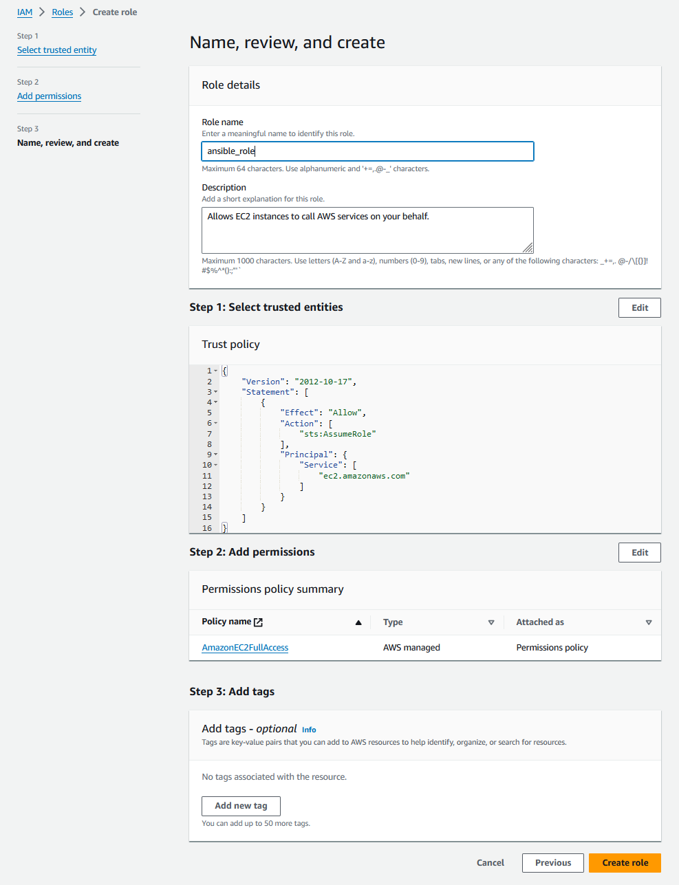

ATTACHED TO THE EC2 INSTANCE ANSIBLE_NODE:

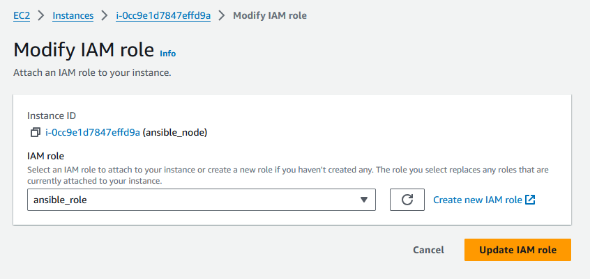

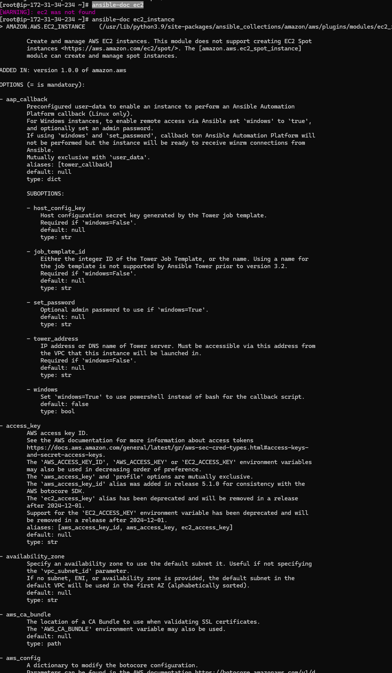

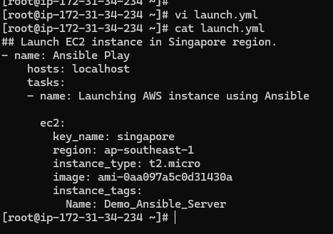

PROBLEM:  
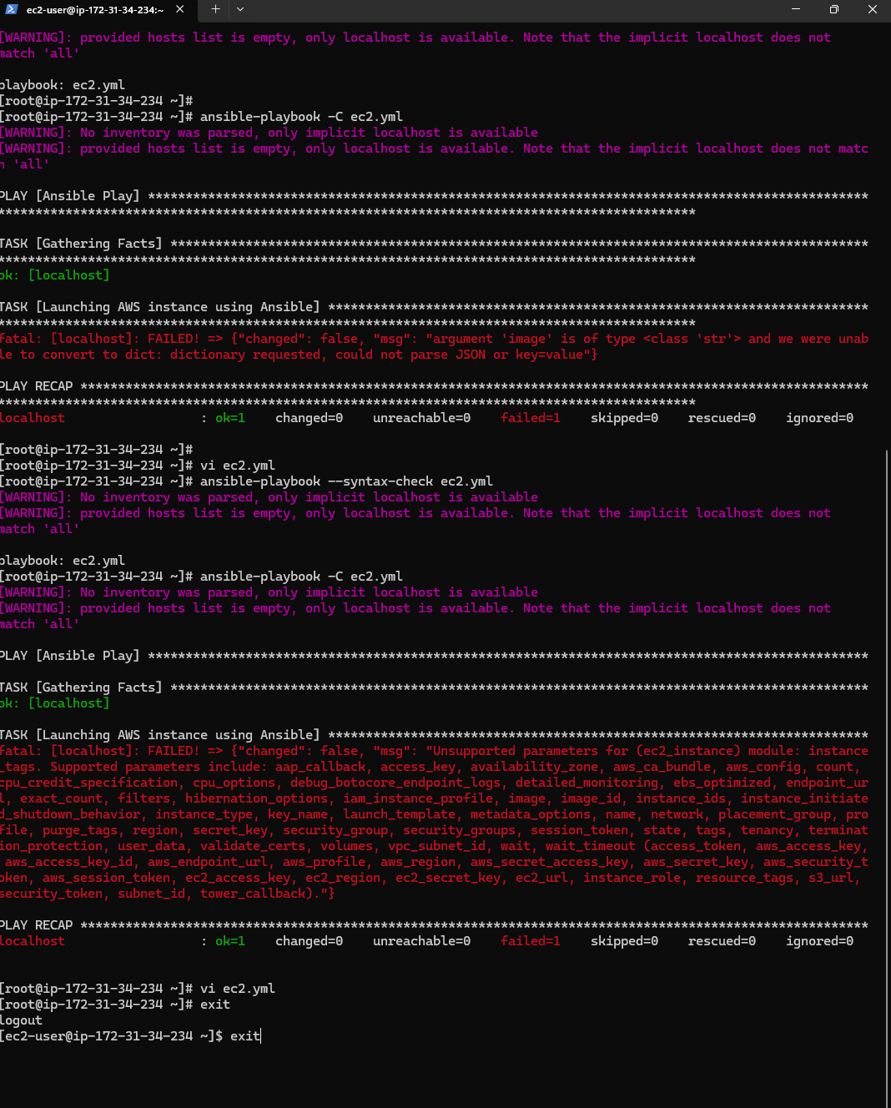

can you check what is wrong in this playbook? 1 ## Launch EC2 instance in Singapore region. 2 - name: Ansible Play 3 hosts: localhost 4 tasks: 5 - name: Launching AWS instance using Ansible 6 7 ec2: 8 key_name: singapore 9 region: ap-southeast-1 10 instance_type: t2.micro 11 image: ami-0aa097a5c0d31430a 12 instance_tags: 13 Name: Demo_Ansible_Server

**ChatGPT said:**

ChatGPT

Your playbook looks mostly correct, but there are a couple of things to check and improve:

1. **Indentation**: The indentation under tasks and ec2 should be consistent. Ensure that each nested level has proper spacing (usually 2 spaces in YAML).
2. **Module name**: The module name should be ec2 or ec2_instance, depending on your version of Ansible. Make sure you're using the correct one.
3. **Missing parameters**: You may want to include parameters like count if you want to specify the number of instances, and wait if you want the playbook to wait until the instance is running.
4. **Credentials**: Ensure you have the proper AWS credentials set up (either through environment variables or a configuration file).

Here’s a revised version of your playbook:

yaml

Copy code

## Launch EC2 instance in Singapore region.

- name: Ansible Play

hosts: localhost

tasks:

- name: Launching AWS instance using Ansible

ec2_instance: # Use ec2_instance for newer versions of Ansible

key_name: singapore

region: ap-southeast-1

instance_type: t2.micro

image: ami-0aa097a5c0d31430a

instance_tags:

Name: Demo_Ansible_Server

wait: yes # Optional: Wait for the instance to be running

count: 1 # Optional: Number of instances to launch

Make sure to test this playbook in a safe environment to confirm that it works as expected.

4o mini

**You said:**

thanks

**ChatGPT said:**

ChatGPT

You're welcome! If you have any more questions or need further assistance with your playbook, feel free to ask. Happy automating!

4o mini

**You said:**

fatal: [localhost]: FAILED! => {"changed": false, "msg": "argument 'image' is of type <class 'str'> and we were unable to convert to dict: dictionary requested, could not parse JSON or key=value"}

**ChatGPT said:**

ChatGPT

The error indicates that the image parameter needs to be specified in a different format. Instead of using a single string for image, you should provide a dictionary format.

Here’s how you can modify your playbook:

yaml

Copy code

## Launch EC2 instance in Singapore region.

- name: Ansible Play

hosts: localhost

tasks:

- name: Launching AWS instance using Ansible

ec2_instance:

key_name: singapore

region: ap-southeast-1

instance_type: t2.micro

image:

id: ami-0aa097a5c0d31430a # Use a dictionary format

instance_tags:

Name: Demo_Ansible_Server

wait: yes

count: 1

This should resolve the error. Let me know if you need more help!

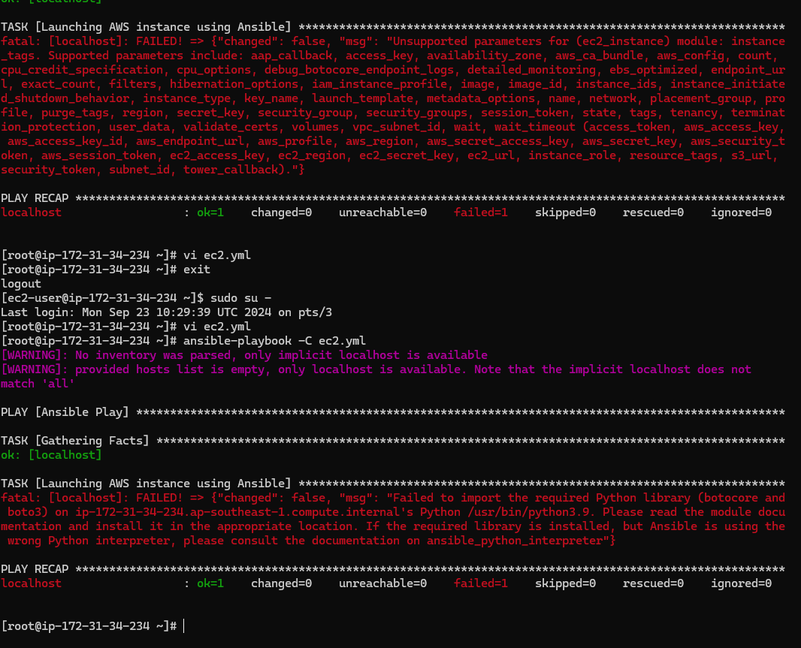

FINAL:  
[root@ip-172-31-34-234 ~]# cat launch-ec2.yml

## Launch EC2 instance in Singapore region.

- name: Ansible Play

hosts: localhost

tasks:

- name: Launching AWS instance using Ansible

ec2_instance: # Use ec2_instance for newer versions of Ansible

key_name: EC2-Tutorial

region: ap-southeast-1

instance_type: t2.micro

image:

id: ami-0aa097a5c0d31430a

tags:

Name: Demo_Ansible_Server

wait: yes # Optional: Wait for the instance to be running

count: 1 # Optional: Number of instances to launch

[root@ip-172-31-34-234 ~]#

STOPPING THE INSTANCE:

stop.yml:

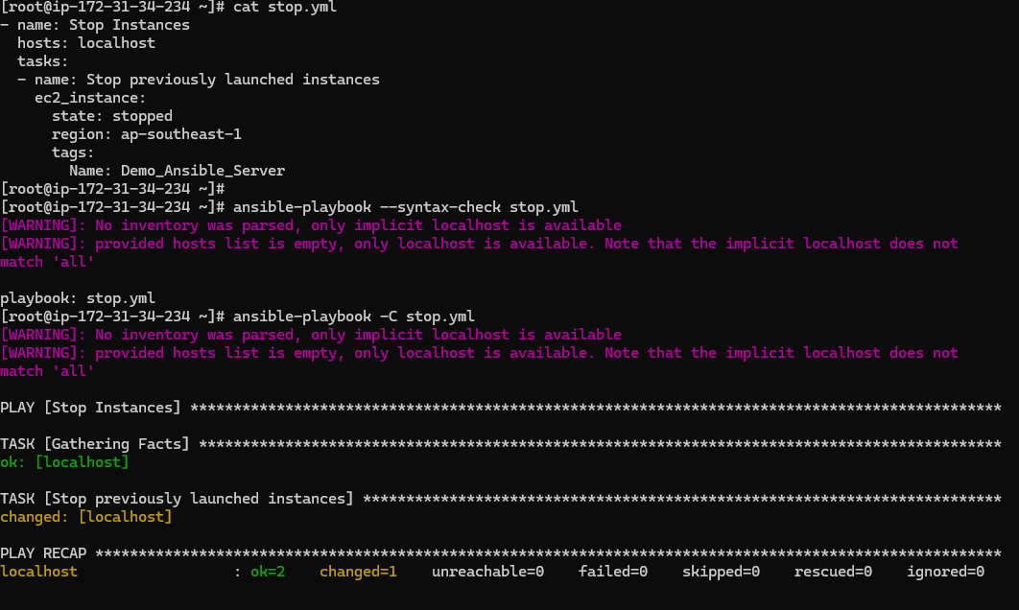

STARTING THE INSTANCE:

start.yml  
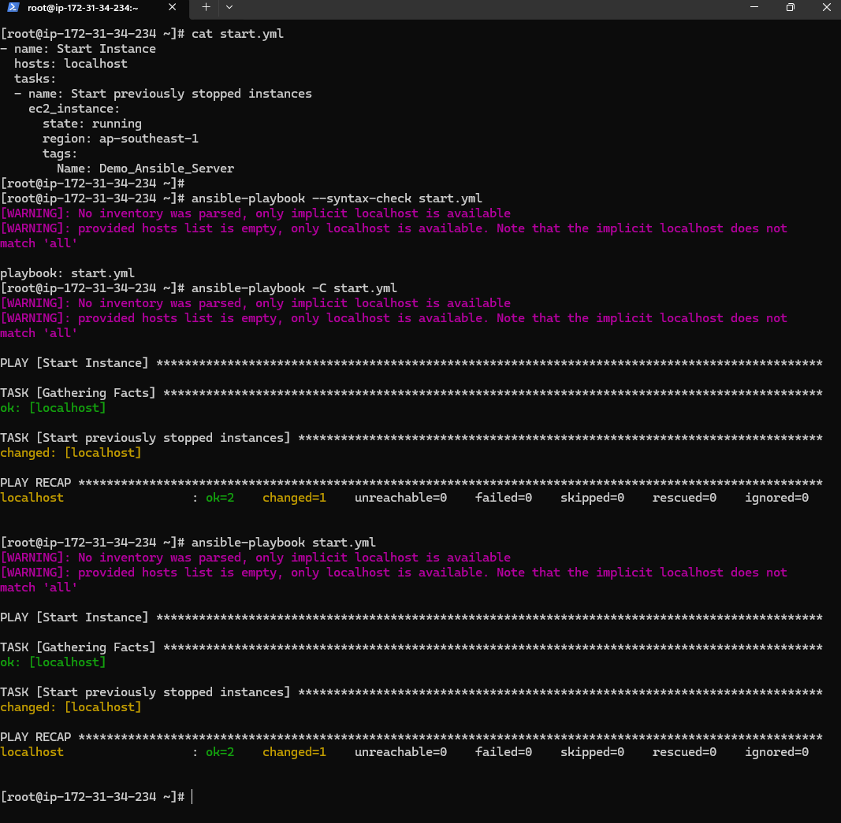

TERMINATE THE INSTANCE:

terminate.yml:



